http://www.brookesnews.com/070511greenspan.html

Greenspan absolves himself from current financial markets turmoil
Dr Frank Shostak
BrookesNews.Com
Monday 5 November 2007
Now that he is no longer the Fed Chairman some financial commentators are daring to suggest that perhaps the present financial crisis is on account of Greenspan’s Fed extremely low interest rate policy between December 2000 to June 2004 that fuelled the housing bubble. The fed funds rate was lowered from 6.5 per cent in December 2000 to 1 per cent by June 2003. It was kept at 1 per cent until June 2004 when the rate was raised by 0.25 per cent. The yearly rate of growth of the S&P — Case — Shiller house price index jumped to 20.5 per cent by July 2004 whilst the average growth of this house price index during 2005 stood at 17 per cent
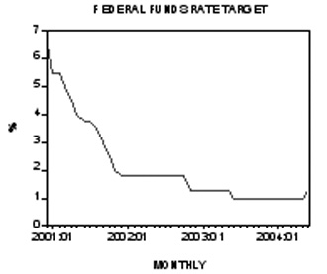
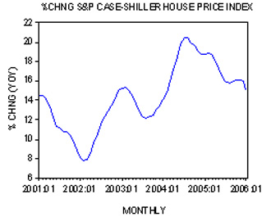
In an interview on October 21 2007 the former Fed chairman rejected the view that his loose monetary policies might have been the source of the current financial markets instability. Greenspan argues that it is extremely low long-term interest rates, which depressed mortgage rates that were the major cause of the housing bubble. According to Greenspan the Fed doesn’t have much control over long-term interest rates. For instance, according to Greenspan, between June 2004 to June 2005 the Fed had embarked on a tighter interest rate stance. The federal funds rate target was lifted from 1 per cent in June 2004 to 3.25 per cent by June 2005. Yet despite this tighter stance the yield on the 10-year T-Note fell from 4.58 per cent in June 2004 to 3.92 per cent by June 2005. As a result of this the 30-year fixed mortgage rate fell from 5.75 per cent in June 2004 to 5.58 per cent in June 2005.
As one can see here long-term interest rates and mortgage interest rate fell whilst the Fed was tightening its stance. So how in the world can the Fed be blamed for the housing bubble and the current financial crisis? According to Greenspan since the Fed doesn’t control long-term interest rates it therefore cannot be seen as the cause behind the present financial market turmoils. In short, the market is to be blamed for the current crisis. We suggest that contrary to Greenspan it is not long-term rates as such that fuelled the bubble but the monetary pumping by the Fed. It is the monetary pumping that depressed the long-term rates and triggered the housing bubble.
We suspect that because of the aggressive lowering of interest rates between December 2000 to June 2003 the Fed had pushed the federal funds rate target below where market conditions would have dictated. This means that to prevent the federal funds rate from overshooting the target the US central bank had to aggressively push money into the economy. The yearly rate of growth of monetary pumping, as depicted by the Fed’s balance sheet also known as Fed Credit, jumped from negative 2.7 per cent in December 2000 to 9.8 per cent as of June 2003. At one stage in September 2001 the yearly rate of growth climbed to 12.2 per cent. The possibility that the fed funds rate target was far too low is also “supported” by the Taylor Rule. According to the Taylor Rule in May 2004 the target was below the so-called “correct” rate by 2.3 per cent.
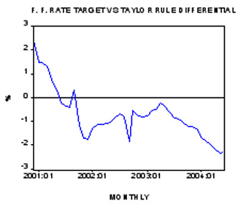
In response to this pumping we suggest that the yield on the 10-year Treasury Note fell from 5.11 per cent in December 2000 to 3.5 per cent by June 2003. During that period the 30-year fixed mortgage interest rate fell from 7.38 per cent to 5.23 per cent. What about the discrepancy between short-term and long-term interest rates during June 2004 and June 2005 that Greenspan presents as the case to absolve himself from current financial instability? Historically the 30-year fixed mortgage rate and the federal funds rate has had a tendency to display a very good visual correlation. This doesn’t mean that the correlation is perfect — a discrepancy in the movements between the fed funds rate and long-term rates can occur. The emergence of a discrepancy doesn’t imply however that all of a sudden Fed’s policies have nothing to do with the housing bubble and boom-bust cycles.
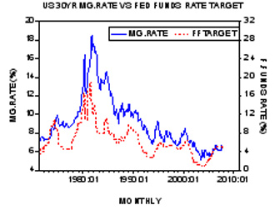
Various discrepancies between the movement in the fed funds rate and the mortgage rate is on account of a time lag effect from changes in monetary policy and economic activity. On account of the time lag a situation could emerge that long term rates could ease notwithstanding the central bank’s tighter interest rate stance. Despite a tighter interest rate stance the past loose interest rate stance may still dominate economic activity. Hence despite a tighter interest rate stance the fed funds rate target could still be too low. In order then to prevent the fed funds rate from overshooting the target the Fed may be forced to push more money into the economy. As a result more money becomes available for financial and bond markets, which puts downward pressure on long-term rates.
In November 2004 the yearly rate of growth of Fed’s Credit (Fed’s balance sheet) jumped to 7.2 per cent from 4.5 per cent in June 2004. Note that this increase in the pace of monetary pumping took place whilst the fed funds rate target was lifted from 1 per cent in June to 2 per cent in November. Also note that between December 2004 and June 2005 the average yearly rate of growth of Fed Credit stood at still elevated 6.2 per cent. (The economic activity was gaining strength during June 2004 to June 2005 — the yearly rate of growth of industrial production climbed from 2.5 per cent in June 2004 to 4.2 per cent by June 2005).
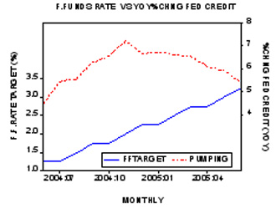
We can thus conclude that the current financial markets instability is more than likely to be the product of Greenspan’s Fed policies. We also suggest that contrary to Greenspan a bubble cannot emerge without a preceding increase in the monetary pumping by the central bank.
Dr Shostak is a former professor of economics who now works in the private sector.

